INTESIVE PROGRAMMING UNIT(IPU)

1. *SIMPLE PYTHON PROGRAMS (1-21)*
   1. Write Python Program to Calculate the Average of Numbers in a Given List

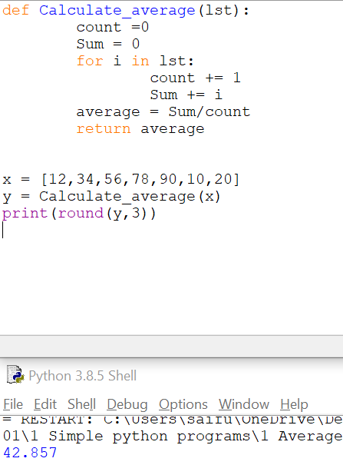

* 1. Write Python Program to Exchange the Values of Two Numbers Without Using a Temporary Variable .

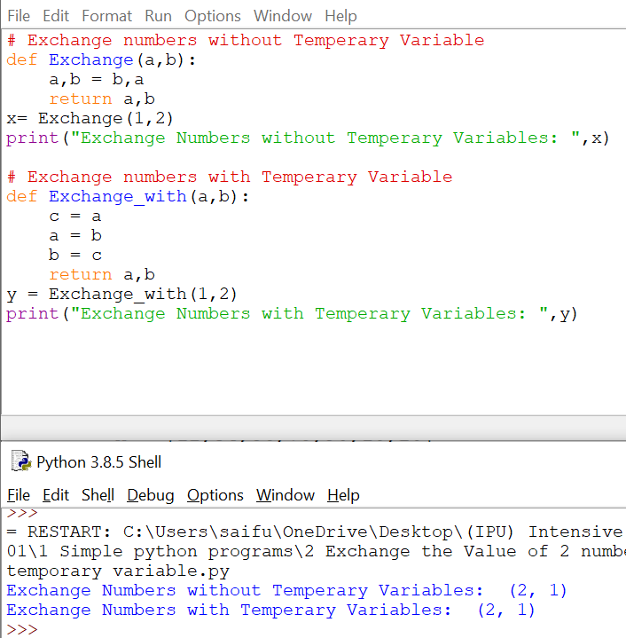

* 1. Write Python Program to Convert Decimal to Binary, Octal and Hexadecimal and vice versa without using built in functions.

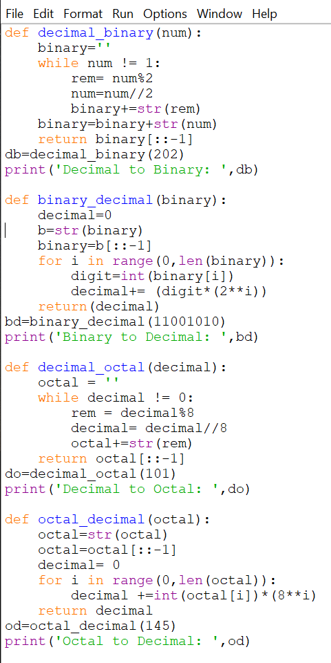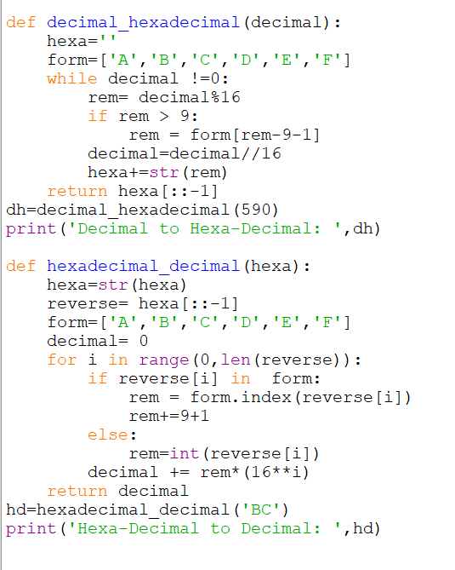

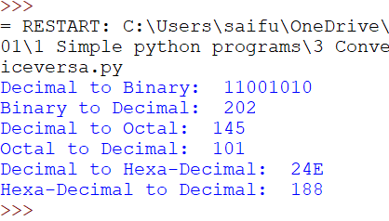

* 1. Write Python Program to Read a Number n and Compute n+nn+nnn

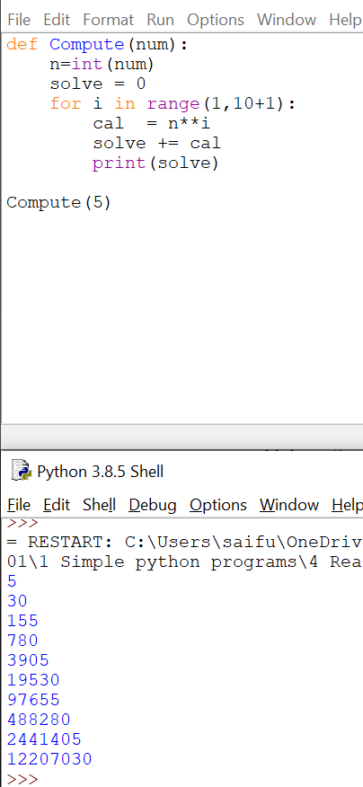

* 1. Write Python Program to Reverse a Given Number

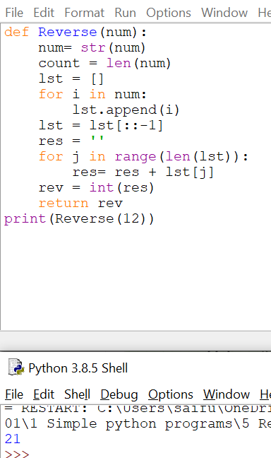

* 1. Write Python Program to Check Whether a Number is Positive or Negative

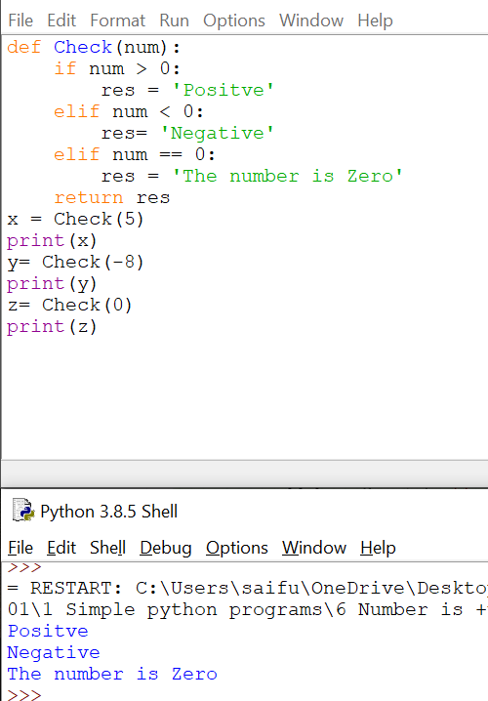

* 1. Write Python Program to Take in the Marks of 5 Subjects and Display the Grade

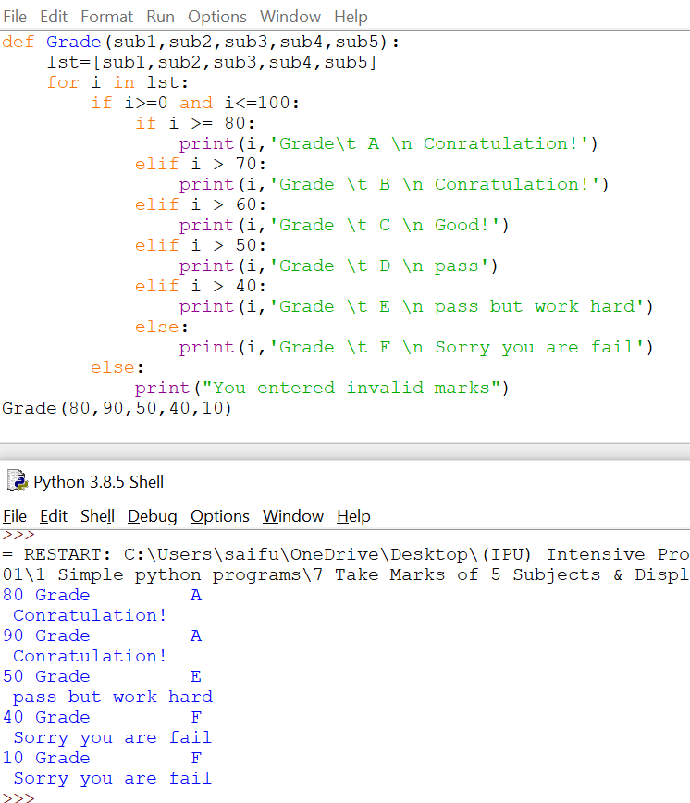

* 1. Write Python Program to Print all Numbers in a Range Divisible by a Given Number

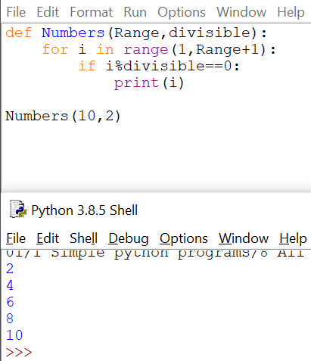

* 1. Write Python Program to Read Two Numbers and Print Their Quotient and Remainder

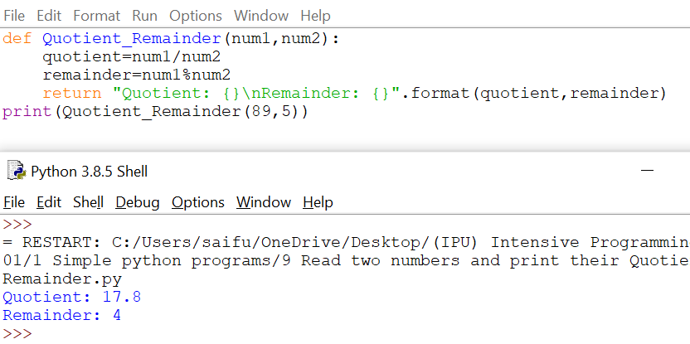

* 1. Write Python Program to Accept Three Digits and Print all Possible Combinations from the Digits

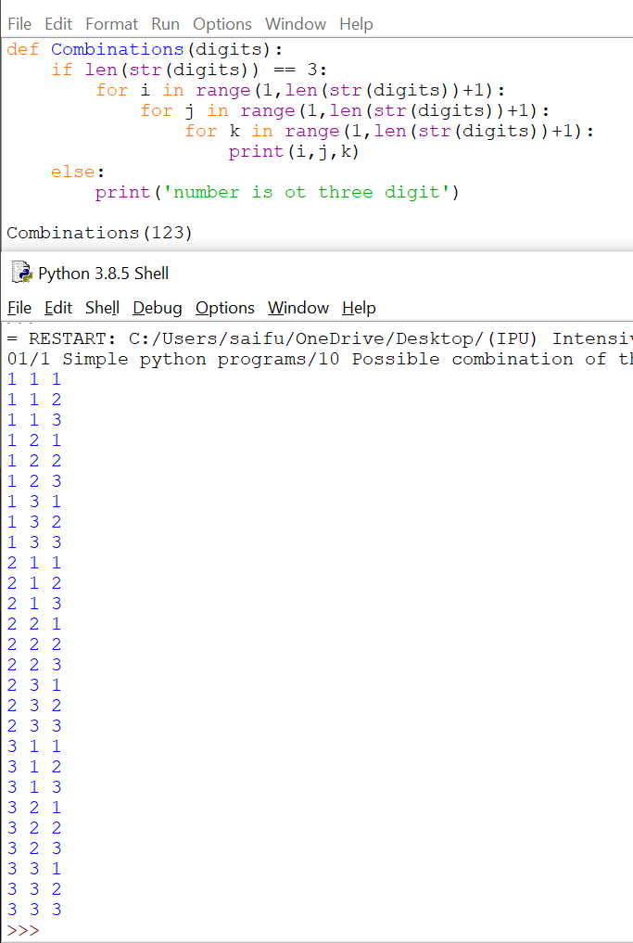

* 1. Write Python Program to Print Odd Numbers Within a Given Range

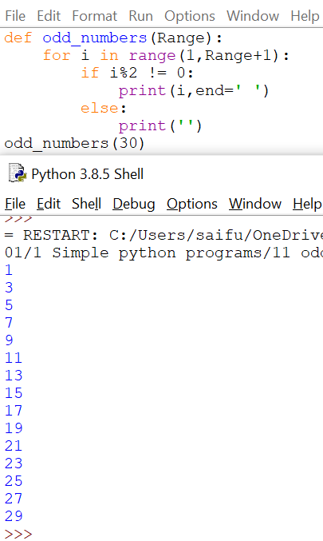

* 1. Write Python Program to Find the Sum of Digits in a Number

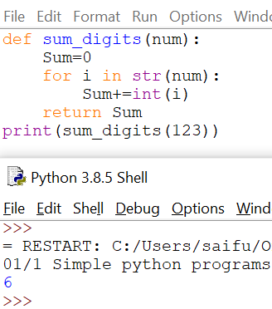

* 1. Write Python Program to Find the Smallest Divisor of an Integer

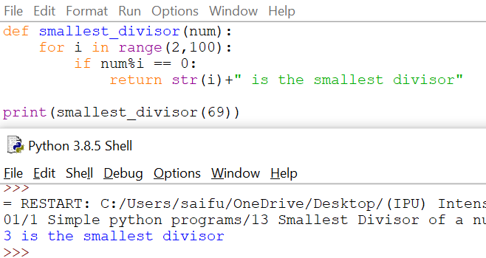

* 1. Write Python Program to Count the Number of Digits in a Number

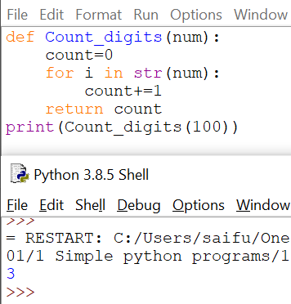

* 1. Write Python Program to Check if a Number is a Palindrome

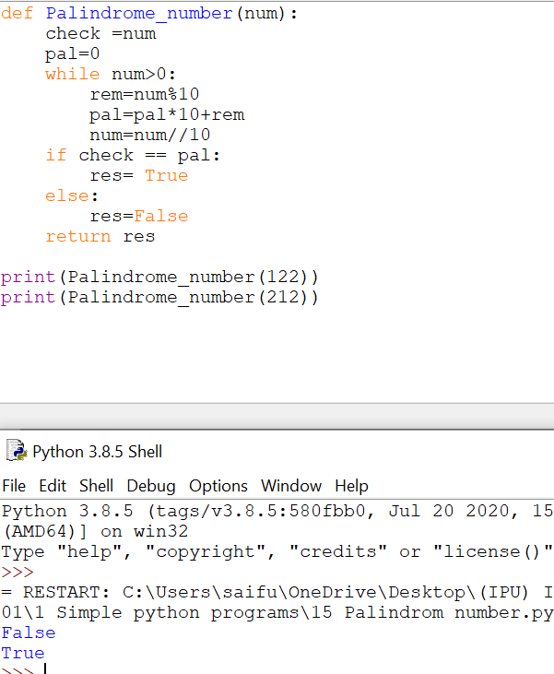

* 1. Write Python Program to Print all Integers that Aren't Divisible by Either 2 or 3 and Lie between 1 and 50.

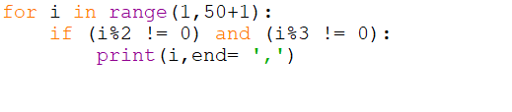

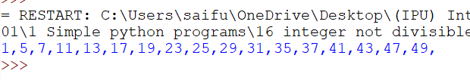

* 1. Write Python Program to Read a Number n And Print the Series "1+2+…..+n= "

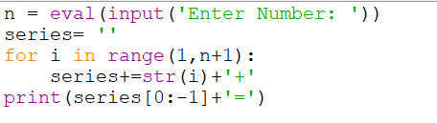

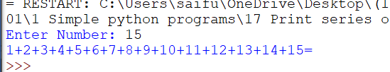

* 1. Write Python Program to Read a Number n and Print the Natural Numbers Summation Pattern

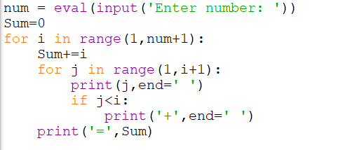

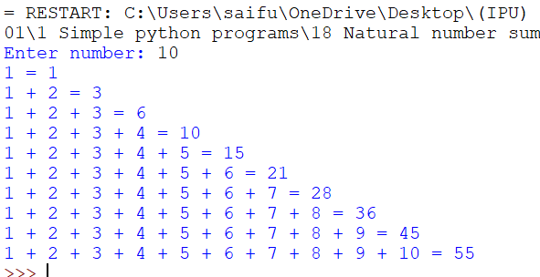

* 1. Write Python Program to Print an Identity Matrix

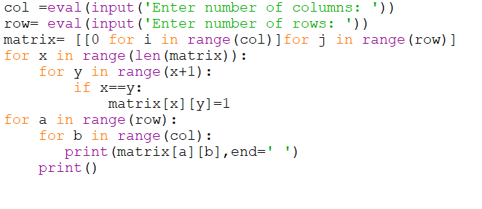

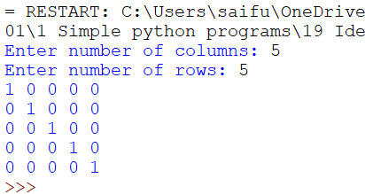

* 1. Write Python Program to Print an Inverted Star Pattern

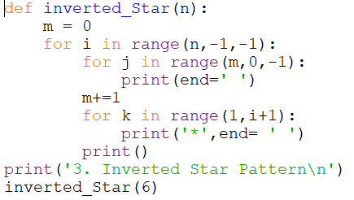

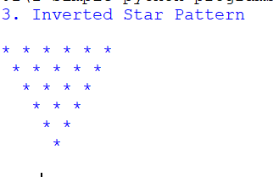

* 1. Write Python Program to Read Print Prime Numbers in a Range using Sieve of Eratosthenes

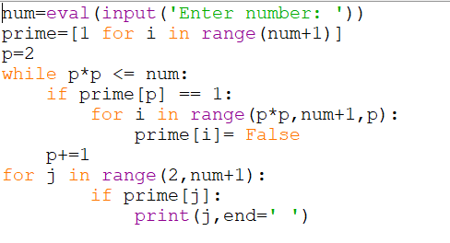

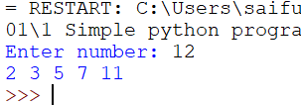

1. *Python Programming Examples on Mathematical Functions (22-50)*
   1. Write Python Program to Check if a Date is Valid and Print the Incremented Date if it is

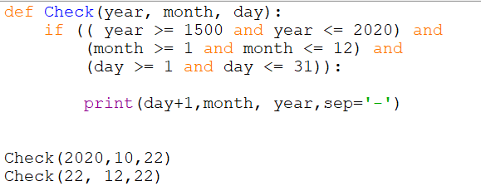

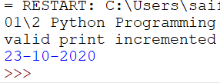

* 1. Write Python Program to Compute Simple Interest Given all the Required Values

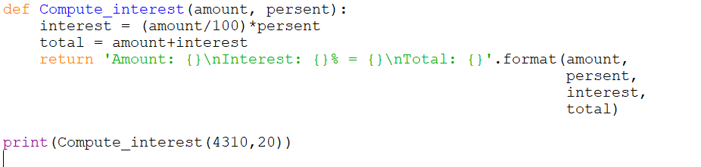

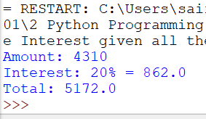

* 1. Write Python Program to Check Whether a Given Year is a Leap Year

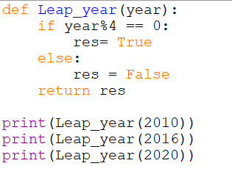

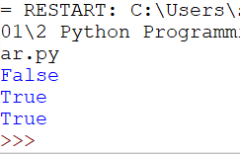

* 1. Write Python Program to Read Height in Centimeters and then Convert the Height to Feet and Inches

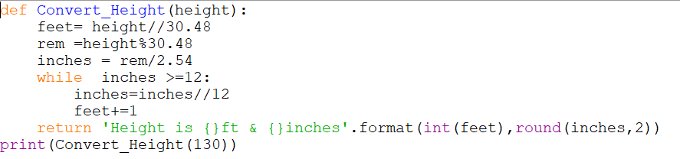

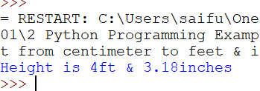

* 1. Write Python Program to Take the Temperature in Celcius and Covert it to Farenheit

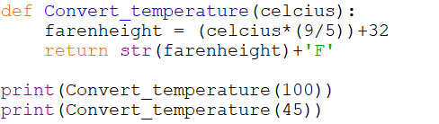

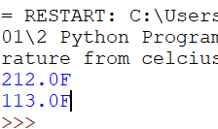

* 1. Write Python Program to Compute Prime Factors of an Integer

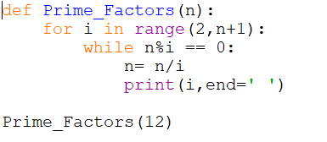

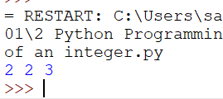

* 1. Write Python Program to Generate all the Divisors of an Integer

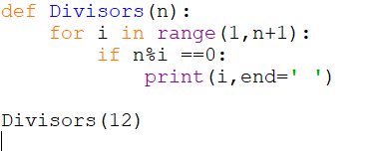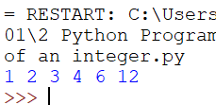

* 1. Write Python Program to Print Table of a Given Number

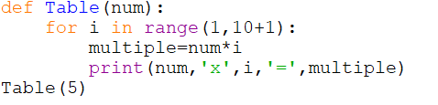

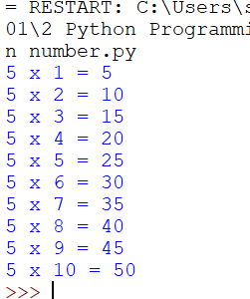

* 1. Write Python Program to Print Sum of Negative Numbers, Positive Even Numbers and Positive Odd numbers in a List

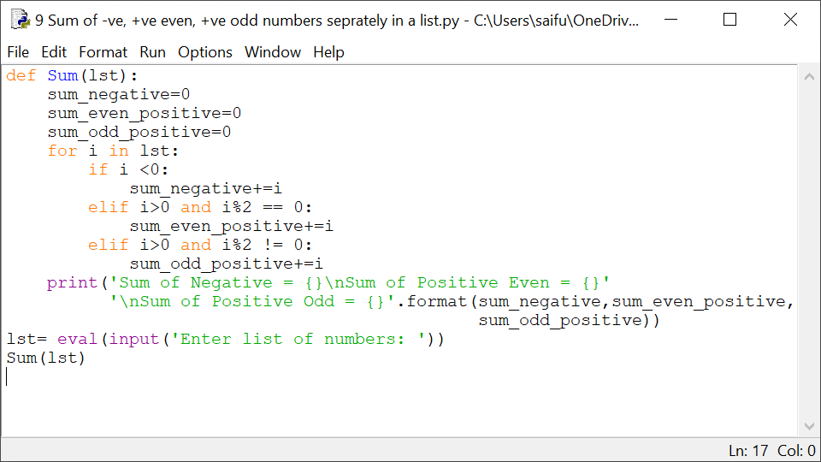

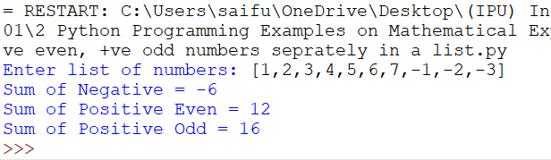

* 1. Write Python Program to Print Largest Even and Largest Odd Number in a List

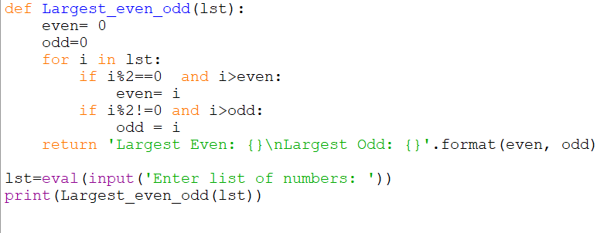

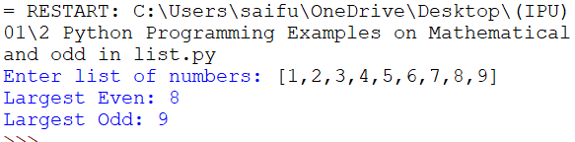

* 1. Write Python Program to Form an Integer that has the Number of Digits at Ten's Place and the Least Significant Digit of the Entered Integer at One's Place

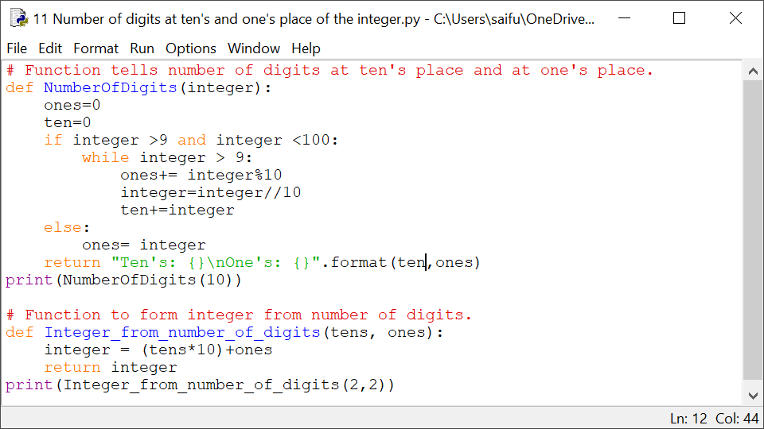

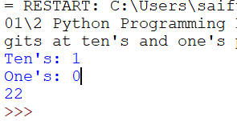

* 1. Write Python Program to Find Those Numbers which are Divisible by 7 and Multiple of 5 in a Given Range of Numbers

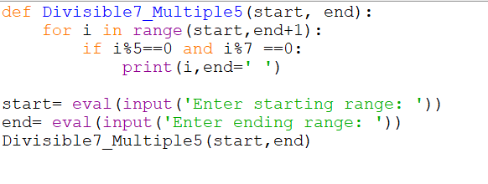

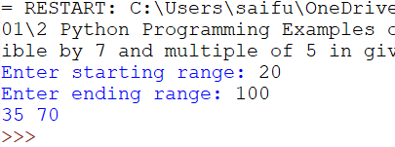

* 1. Write Python Program to Check if a Number is an Armstrong Number

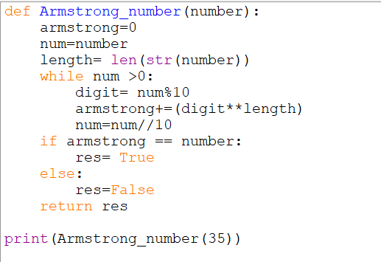

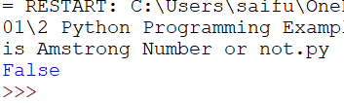

* 1. Write Python Program to Print the Pascal's triangle for n number of rows given by the user

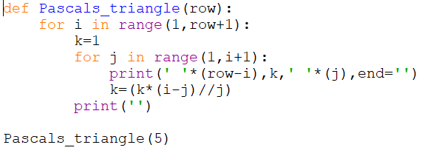

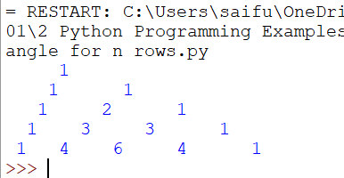

* 1. Write Python Program to Check if a Number is a Perfect Number

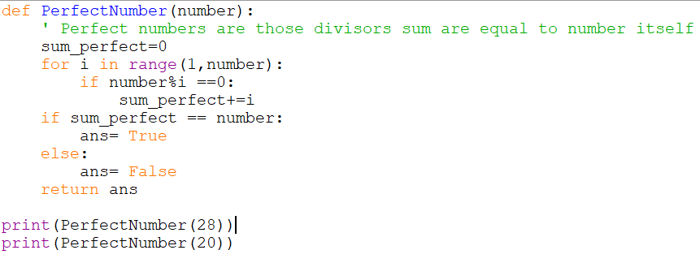

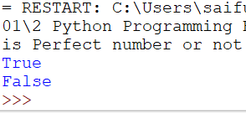

* 1. Write Python Program to Check if a Number is a Strong Number

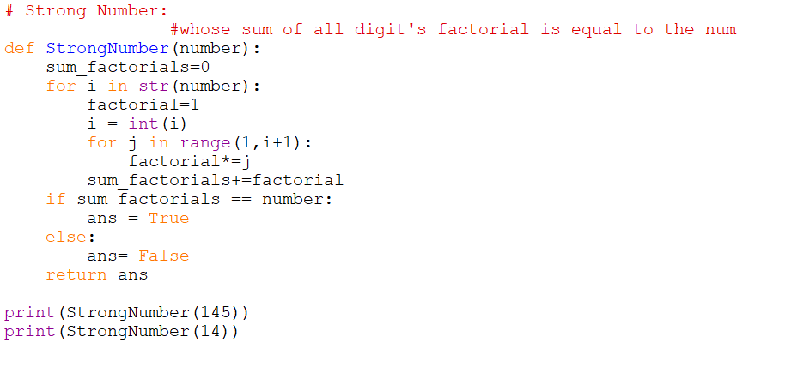

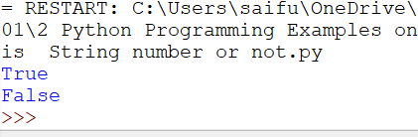

* 1. Write Python Program to Find the LCM of Two Numbers

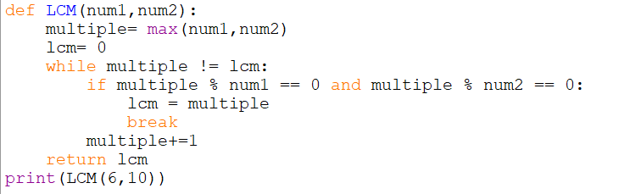

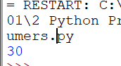

* 1. Write Python Program to Find the GCD of Two Numbers

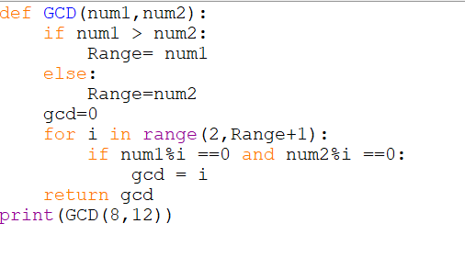

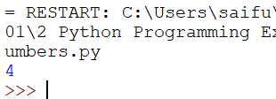

* 1. Write Python Program to Compute a Polynomial Equation given that the Coefficients of the Polynomial are stored in a List

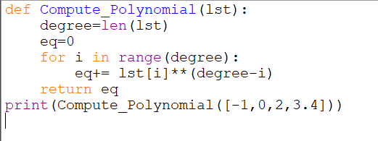

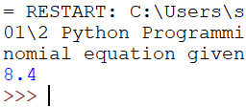

* 1. Write Python Program to Check If Two Numbers are Amicable Numbers

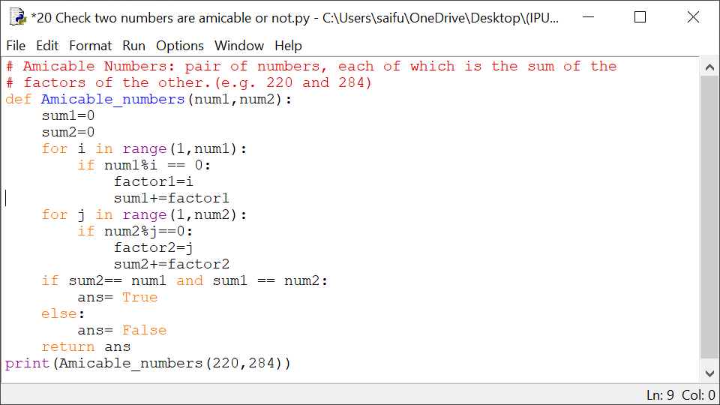

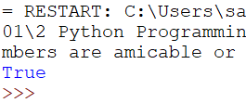

* 1. Write Python Program to Find the Area of a Triangle Given All Three Sides

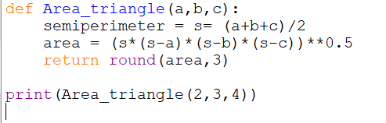

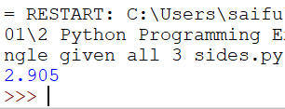

* 1. Write Python Program to Find the Gravitational Force Acting Between Two Objects

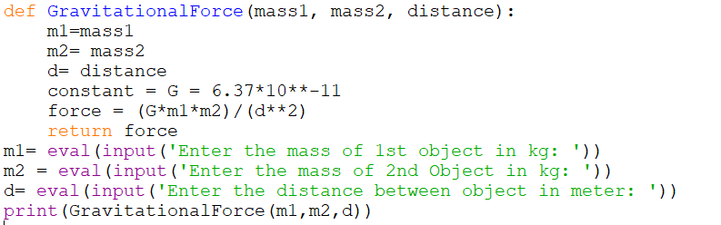

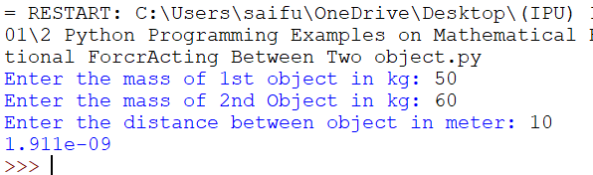

* 1. Write Python Program to Check if a Number is a Prime Number

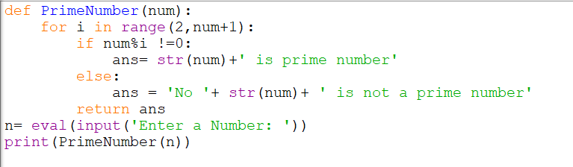

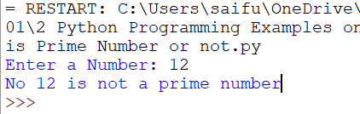

* 1. Write Python Program to Print all the Prime Numbers within a Given Range

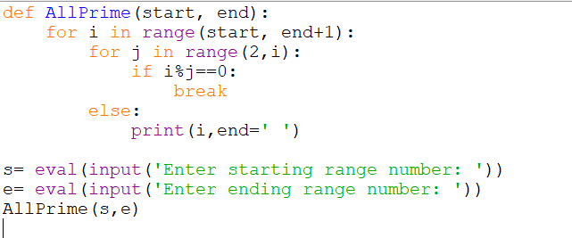

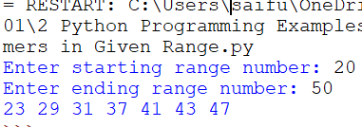

* 1. Write Python Program to Print Numbers in a Range (1,upper) Without Using any Loops

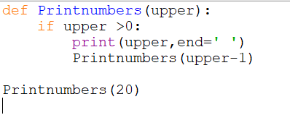

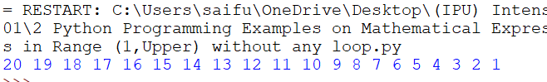

* 1. Write Python Program to Find the Sum of Sine Series
  2. Write Python Program to Find the Sum of Cosine Series
  3. Write Python Program to Find the Sum of First N Natural Numbers

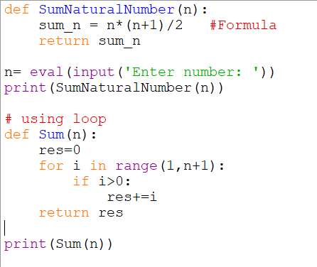

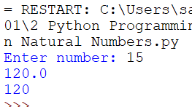

* 1. Write Python Program to Find the Sum of the Series: 1 + 1/2 + 1/3 + ….. + 1/N

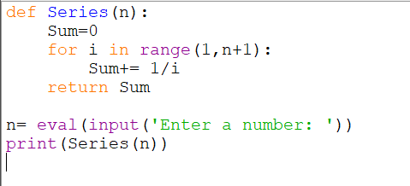

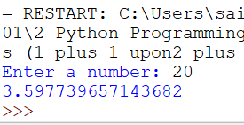

* 1. Write Python Program to Find the Sum of the Series: 1 + x^2/2 + x^3/3 + … x^n/n
  2. Write Python Program to Compute the Value of Euler's Number e. Use the Formula: e = 1 + 1/1! + 1/2! + …… 1/n!

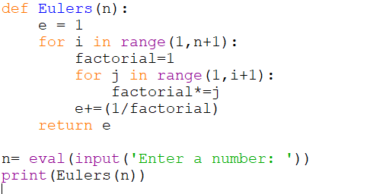

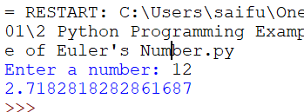

* 1. Write Python Program to Determine all Pythagorean Triplets in the Range
  2. Write Python Program to Search the Number of Times a Particular Number Occurs in a List

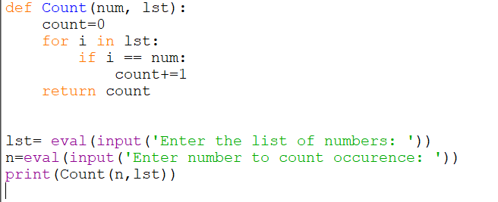

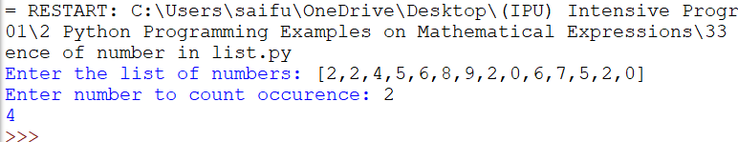

1. *Python Programming Examples on Lists (51-64)*
   1. Write Python Program to Find the Largest Number in a List

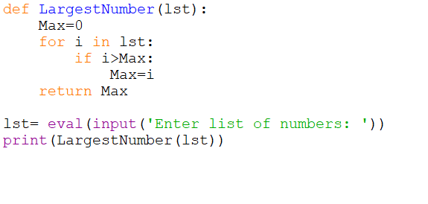

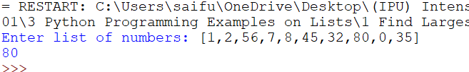

* 1. Write Python Program to Find the Second Largest Number in a List

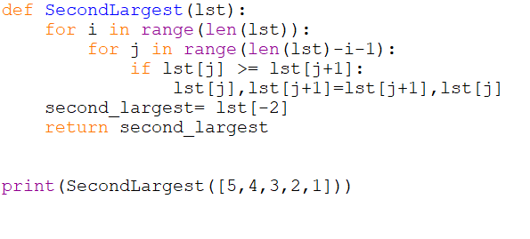

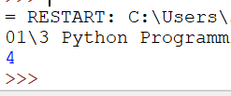

* 1. Write Python Program to Put Even and Odd elements in a List into Two Different Lists

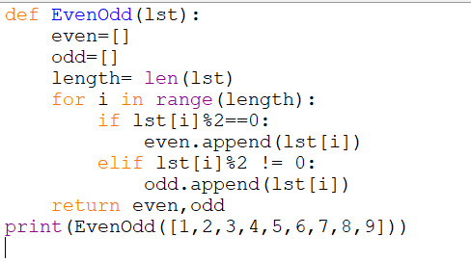

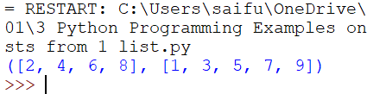

* 1. Write Python Program to Merge Two Lists and Sort it

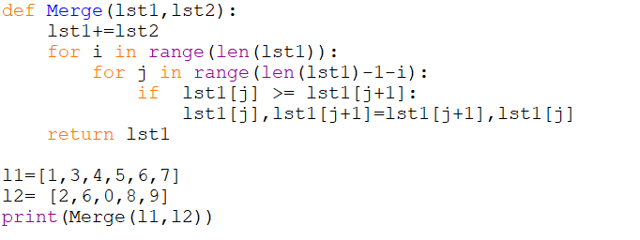

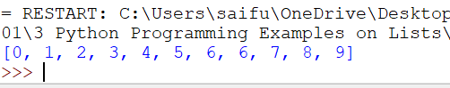

* 1. Write Python Program to Sort the List According to the Second Element in Sublist
  2. Write Python Program to Find the Second Largest Number in a List Using Bubble Sort

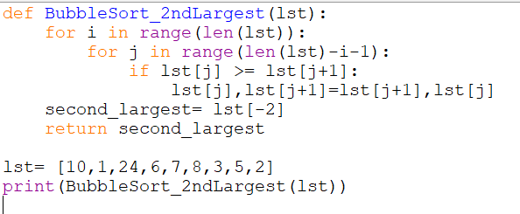

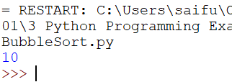

* 1. Write Python Program to Sort a List According to the Length of the Elements

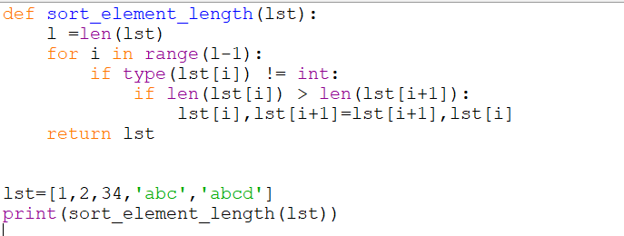

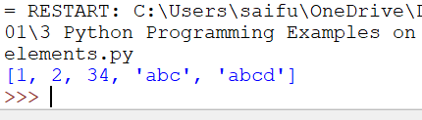

* 1. Write Python Program to Find the Union of two Lists

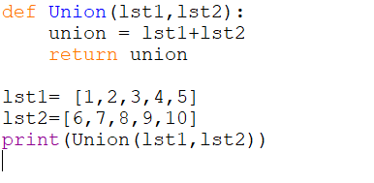

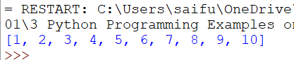

* 1. Write Python Program to Find the Intersection of Two Lists

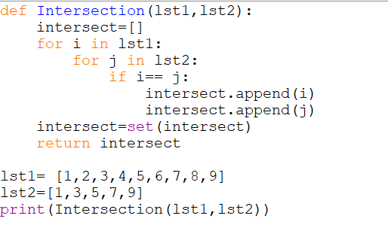

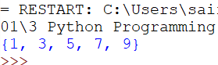

* 1. Write Python Program to Create a List of Tuples with the First Element as the Number and Second Element as the Square of the Number

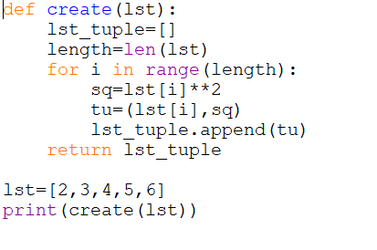

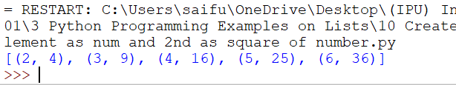

* 1. Write Python Program to Find all Numbers in a Range which are Perfect Squares and Sum of all Digits in the Number is Less than 10

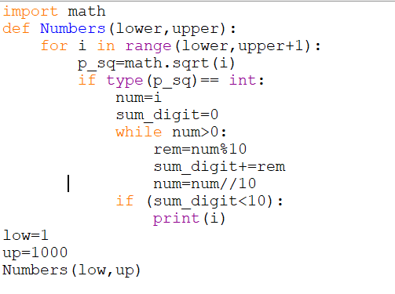

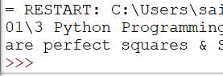

* 1. Write Python Program to Find the Cumulative Sum of a List where the ith Element is the Sum of the First i+1 Elements From The Original List.
  2. Write Python Program to Generate Random Numbers from 1 to 20 and Append Them to the List .
  3. Write Python program to Sort a List of Tuples in Increasing Order by the Last Element in Each Tuple.
  4. Write Python Program to Swap the First and Last Value of a List

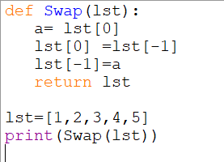

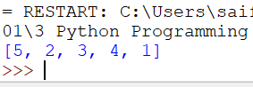

* 1. Write Python Program to Remove the Duplicate Items from a List

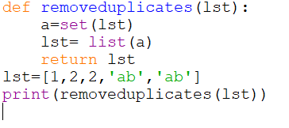

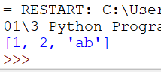

* 1. Write Python Program to Read a List of Words and Return the Length of the Longest One

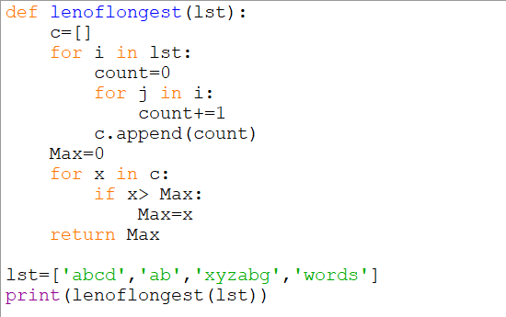

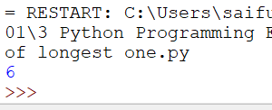

* 1. Write Python Program to Remove the ith Occurrence of the Given Word in a List where Words can Repeat

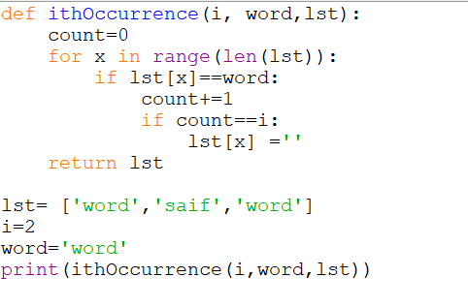

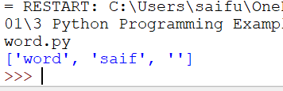

* 1. Write Python Program to Remove All Tuples in a List of Tuples with the USN Outside the Given Range

1. *Python Programming Examples on Strings (65-80)*
   1. Write Python Program to Replace all Occurrences of ‘a’ with $ in a String

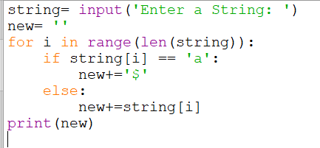

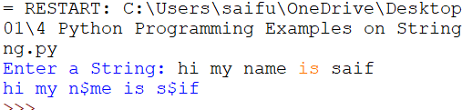

* 1. Write Python Program to Remove the nth Index Character from a Non-Empty String

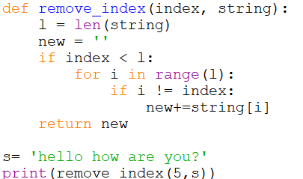

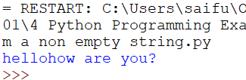

* 1. Write Python Program to Detect if Two Strings are Anagrams .
  2. Write Python Program to Form a New String where the First Character and the Last Character have been Exchanged

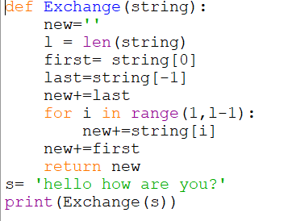

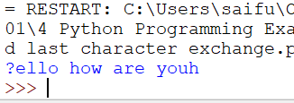

* 1. Write Python Program to Count the Number of Vowels in a String

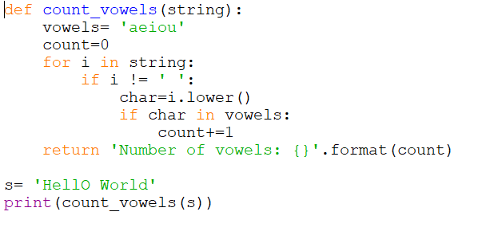

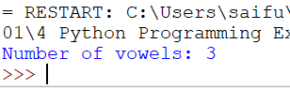

* 1. Write Python Program to Take in a String and Replace Every Blank Space with Hyphen

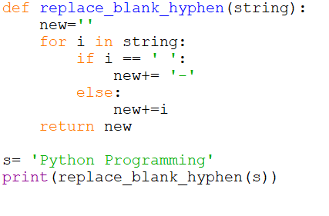

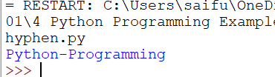

* 1. Write Python Program to Calculate the Length of a String Without Using a Library Function

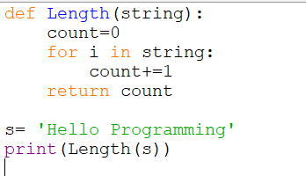

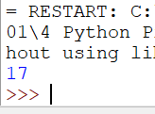

* 1. Write Python Program to Remove the Characters of Odd Index Values in a String

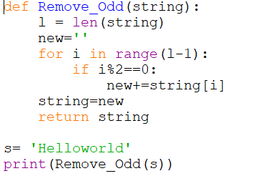

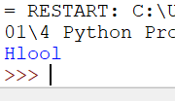

* 1. Write Python Program to Calculate the Number of Words and the Number of Characters Present in a String

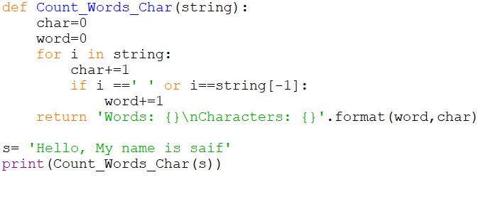

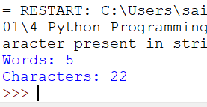

* 1. Write Python Program to Take in Two Strings and Display the Larger String without Using Built-in Functions

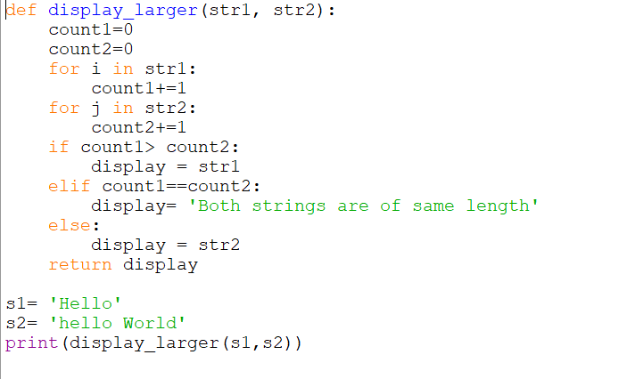

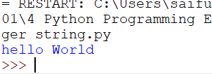

* 1. Write Python Program to Count Number of Lowercase Characters in a String

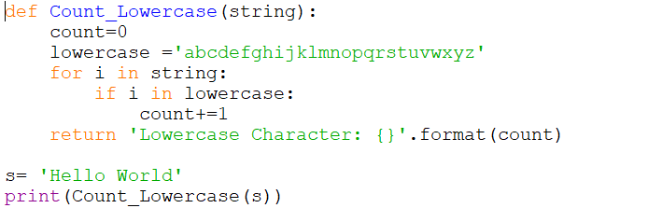

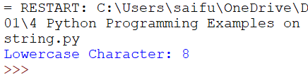

* 1. Write Python Program to Check if a String is a Palindrome or Not

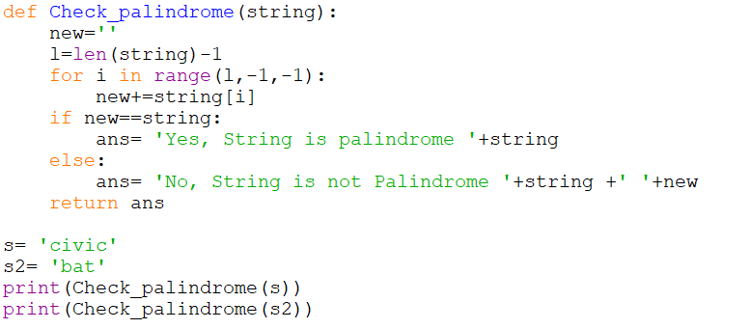

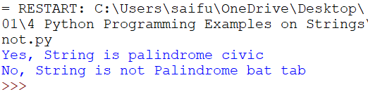

* 1. Write Python Program to Calculate the Number of Upper Case Letters and Lower Case Letters in a String

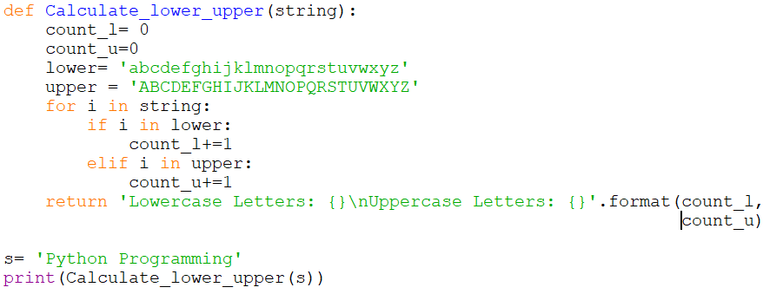

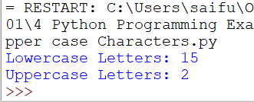

* 1. Write Python Program to Check if a String is a Pangram or Not
  2. Write Python Program to Accept a Hyphen Separated Sequence of Words as Input and
  3. Write Print the Words in a Hyphen-Separated Sequence after Sorting them Alphabetically
  4. Write Python Program to Calculate the Number of Digits and Letters in a String

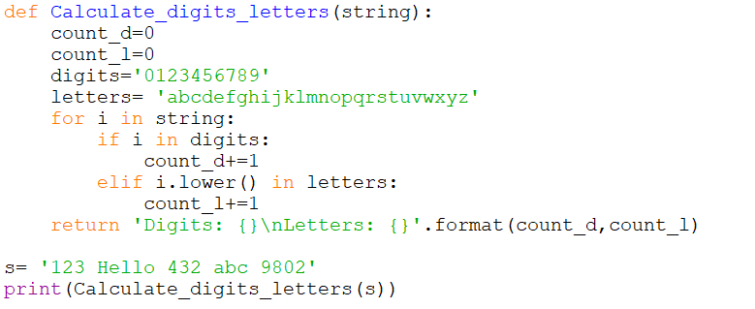

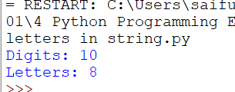

* 1. Write Python Program to Form a New String Made of the First 2 and Last 2 characters From a Given String

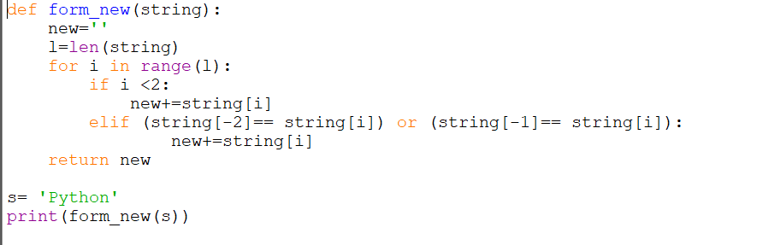

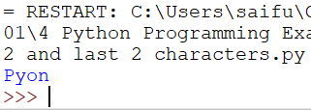

* 1. Write Python Program to Count the Occurrences of Each Word in a Given String Sentence

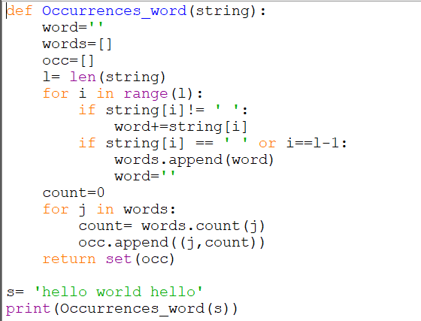

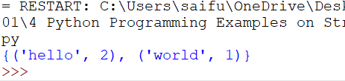

* 1. Write Python Program to Check if a Substring is Present in a Given String

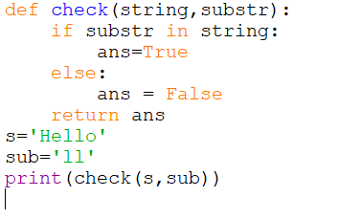

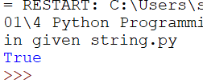

1. *Python Programming Examples on Dictionary (81-87)*
   1. Write Python Program to Add a Key-Value Pair to the Dictionary

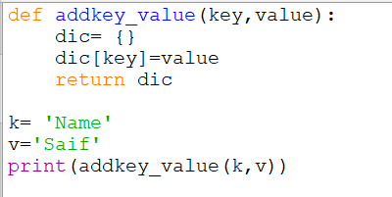

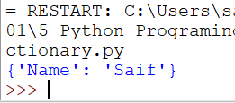

* 1. Write Python Program to Concatenate Two Dictionaries Into One

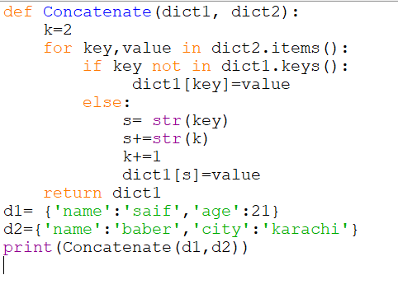

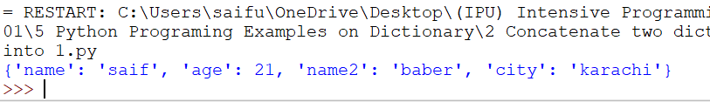

* 1. Write Python Program to Check if a Given Key Exists in a Dictionary or Not

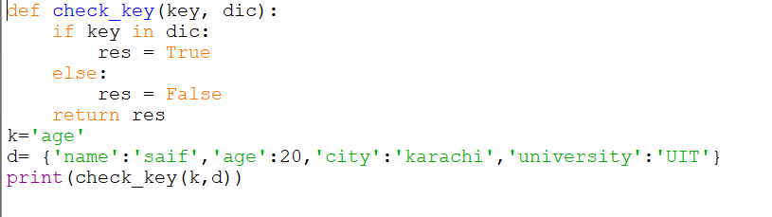

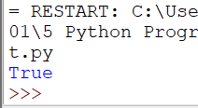

* 1. Write Python Program to Generate a Dictionary that Contains Numbers (between 1 and n) in the Form (x,x\*x).

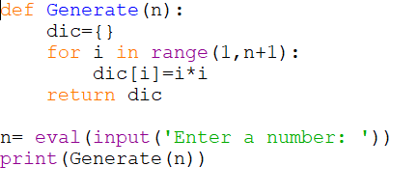

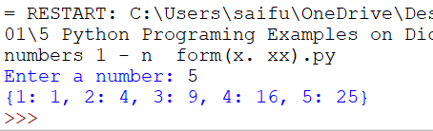

* 1. Write Python Program to Sum All the Items in a Dictionary
  2. Write Python Program to Multiply All the Items in a Dictionary
  3. Write Python Program to Remove the Given Key from a Dictionary

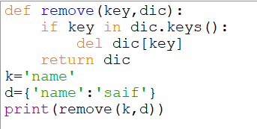

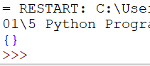

* 1. Write Python Program to Form a Dictionary from an Object of a Class
  2. Write Python Program to Map Two Lists into a Dictionary

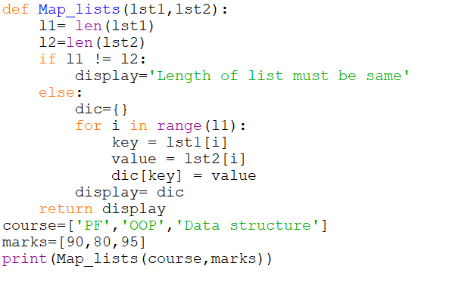

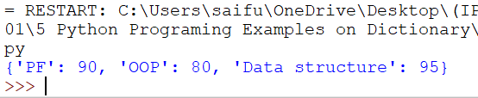

* 1. Write Python Program to Count the Frequency of Words Appearing in a String Using a Dictionary
  2. Write Python Program to Create a Dictionary with Key as First Character and Value as Words Starting with that Character

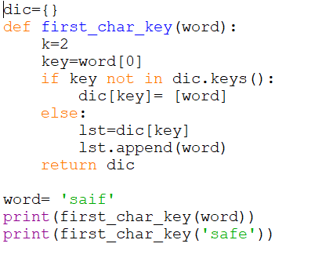

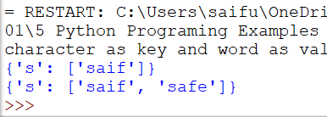

1. *Python Programming Examples on Sets (87-90)*
   1. Write Python Program to Count the Number of Vowels Present in a String using Sets

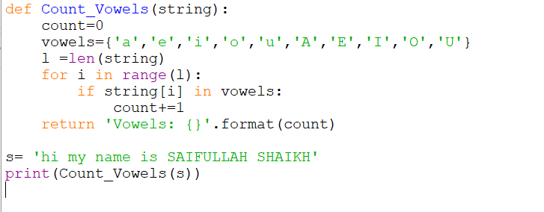

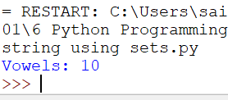

* 1. Write Python Program to Check Common Letters in Two Input Strings

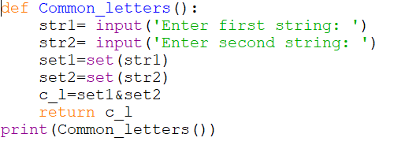

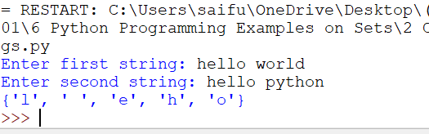

* 1. Write Python Program that Displays which Letters are in the First String but not in the Second

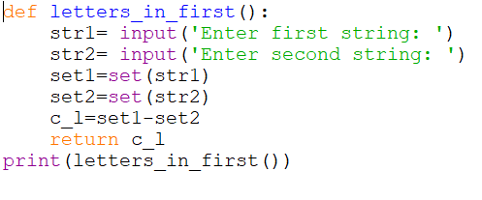

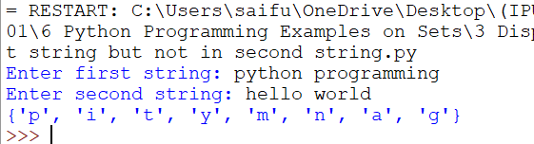

* 1. Write Python Program that Displays which Letters are Present in Both the Strings
  2. Write Python Program that Displays which Letters are in the Two Strings but not in Both